**DAY 12**

**01.07.2023**

**Recurrent Neural Networks**

Recurrent neural networks (RNNs) are a class of neural network that are helpful in modelling sequence data. Derived from feedforward networks, RNNs exhibit similar behaviour to how human brains function. Simply put: recurrent neural networks produce predictive results in sequential data that other algorithms can't.

***Types Of RNN***

There are four types of RNNs based on the number of inputs and outputs in the network.

* One to One
* One to Many
* Many to One
* Many to Many

***One to One***

This type of RNN behaves the same as any simple Neural network it is also known as Vanilla Neural Network. In this Neural network, there is only one input and one output.

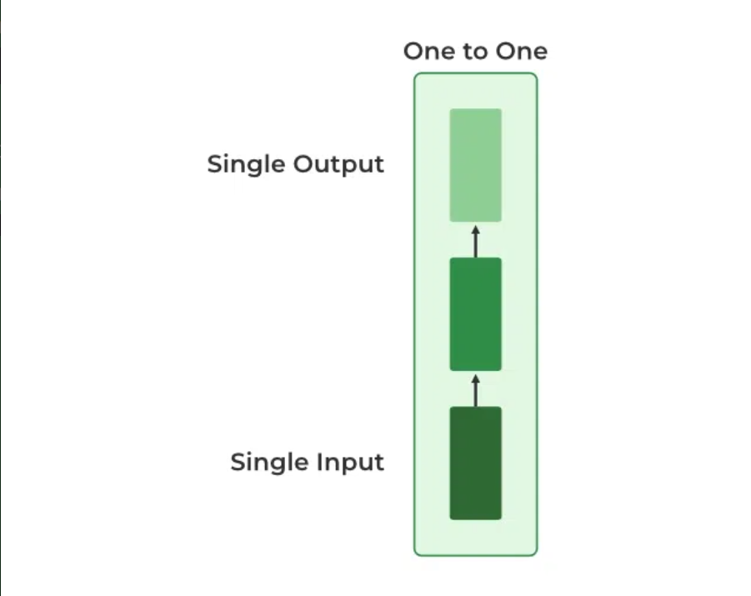



*One to One RNN*

***One to Many***

In this type of RNN, there is one input and many outputs associated with it. One of the most used examples of this network is Image captioning where given an image we predict a sentence having Multiple words.

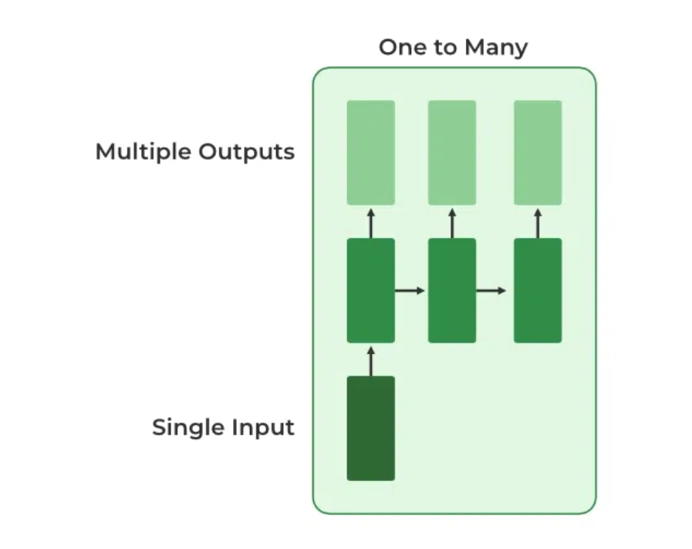

*One to Many RNN*

***Many to One***

In this type of network, many inputs are fed to the network at several states of the network generating only one output. This type of network is used in the problems like sentimental analysis. Where we give multiple words as input and predict only the sentiment of the sentence as output.

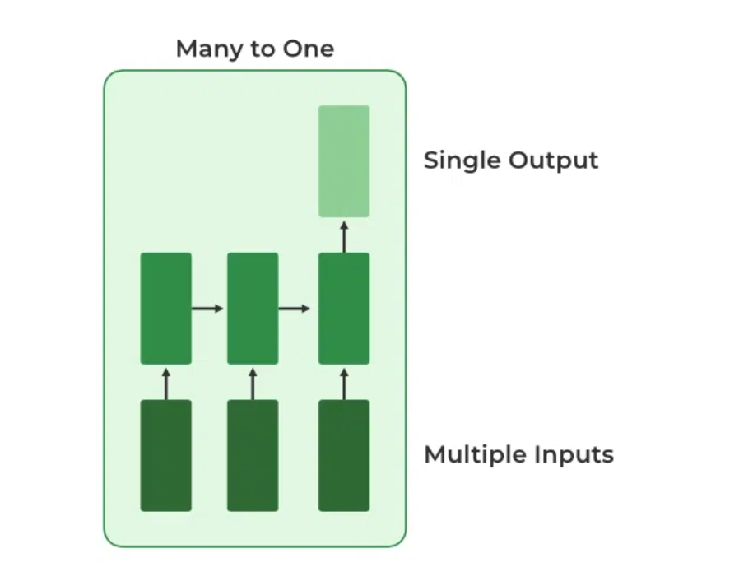

*Many to One RNN*

***Many to Many***

In this type of neural network, there are multiple inputs and multiple outputs corresponding to a problem. One Example of this Problem will be language translation. In language translation, we provide multiple words from one language as input and predict multiple words from the second language as output.

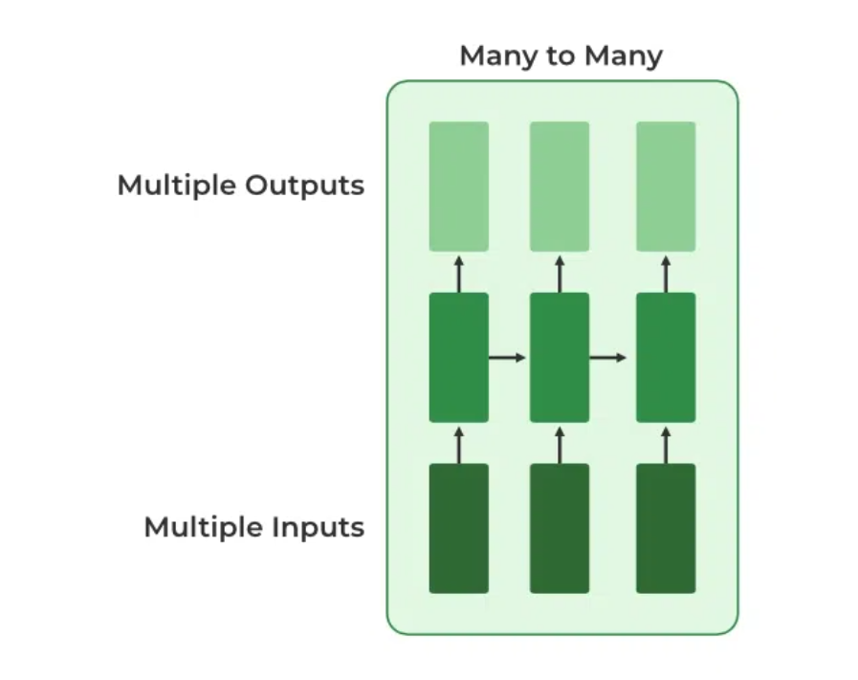

*Many to Many RNN*

***Variation Of Recurrent Neural Network (RNN)***

To overcome the problems like vanishing gradient and exploding gradient descent several new advanced versions of RNNs are formed. They are

* Bidirectional Neural Network (BiNN)
* Long Short-Term Memory (LSTM)

***Bidirectional Neural Network (BiNN)***

A BiNN is a variation of a Recurrent Neural Network in which the input information flows in both direction and then the output of both directions are combined to produce the input. BiNN is useful in situations when the context of the input is more important such as NLP tasks and Time-series analysis problems.

***Long Short-Term Memory (LSTM)***

[Long Short-Term Memory](https://www.geeksforgeeks.org/deep-learning-introduction-to-long-short-term-memory/) works on the read-write-and-forget principle where given the input information network reads and writes the most useful information from the data and it forgets about the information which is not important in predicting the output. For doing these three new gates are introduced in the RNN. In this way, only the selected information is passed through the network.

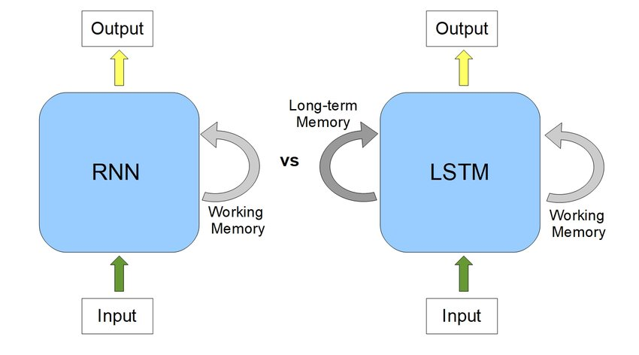

**References**

<https://www.simplilearn.com/tutorials/deep-learning-tutorial/rnn>

<https://www.javatpoint.com/recurrent-neural-network-in-tensorflow>

<https://www.geeksforgeeks.org/introduction-to-recurrent-neural-network/>

[https//machinelearningmastery.com/an-introduction-to-recurrent-neural-networks-and-the-math-that-powers-them/](https://machinelearningmastery.com/an-introduction-to-recurrent-neural-networks-and-the-math-that-powers-them/)